# **Filters**

Task 1 – High pass filters

The following kernel can be used to implement an **emboss** filter:

emboss = [-2, -1, 0;

-1, 1, 1;

0, 1, 2 ];

1. Why does the above kernel constitute a ‘derivative mask’ or ‘high-pass filter’?
2. Create a function which can apply this filter on a grayscale image and return the resultant image. Call the function and display the result next to the original image.

Task 2 – Image Smoothing

1. Research about image smoothing. What is it and what is it used for?
2. What is the difference between Averaging, Median and Gaussian blur filters?
3. Take an image, add Gaussian noise and salt and pepper noise, compare the effect of blurring via box (averaging), median and gaussian filters for both noisy images, as you change the level of noise.
4. Write a program that applies cv2.boxFilter() and cv2.bilateralFilter(). Display the original image and the two results obtained from the two functions. Comment on the results.

Task 3

1. Blurring with a mean filter does not really replicate the effect of a defocused lens. The latter can be better replicated using another type of blur, called Gaussian Blur. A gaussian kernel gives less weight to the pixels further from the center of the window (similar to a defocused lens).

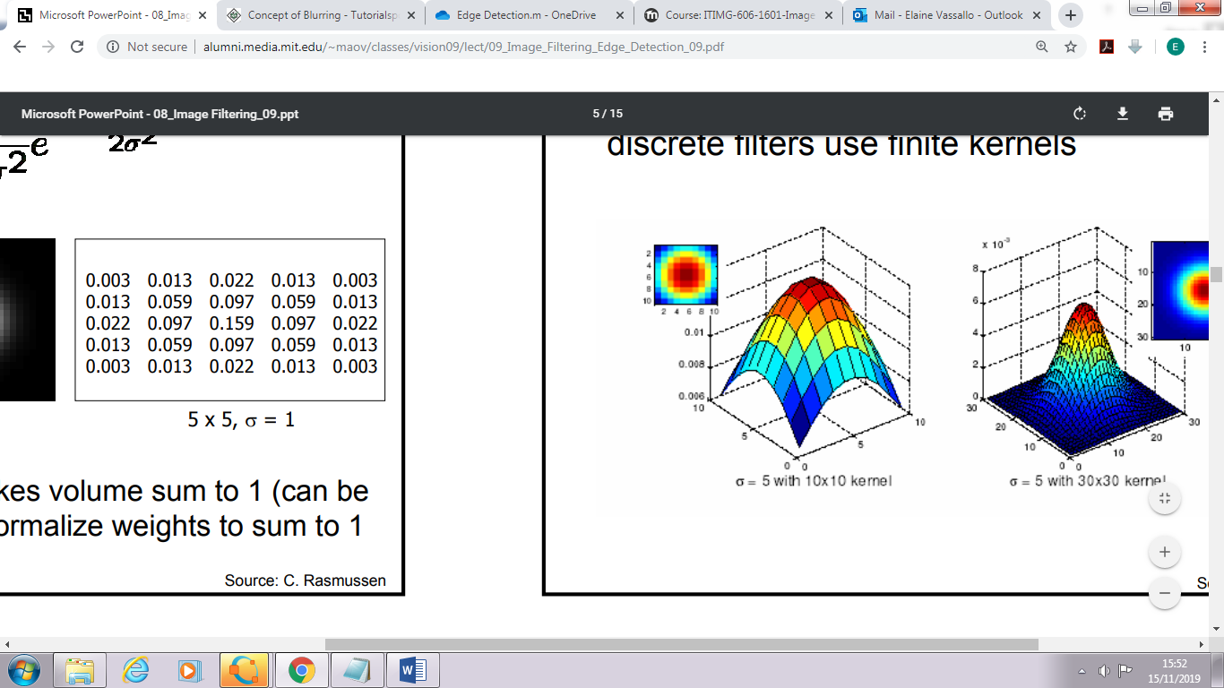

gaussian = 1/16 [1,2,1;

2,4,2;

1,2,1]

Create a function which creates this kernel, apply this filter on a grayscale image and return the resultant image. Call the function and display the result next to the original image.